Cognizant Foundry Platform
QA Test Results
Version No. 1.0



 | Prepared By / Last Updated By | Reviewed by | Approved By
Name | Srividhya Srinath
Role | Test Analyst
Signature
Date | 26-12-2016

User Stories
Story Id 124481901 –
As a System, in MySql manual vertical scale-in needs to be implemented through REST service.

Test cases
MySQL Vertical Scale IN: (Dedicate Cluster Plan)
Verify whether user should able to create the service instance using Dedicate Cluster plan for MySQL
Verify whether user should able to see the VM in Bosh server
Verify whether user should able to do the scale in (decrease the VMtype) for MySQLDB by using MySQLDB-service id in REST API call
Verify whether user should able to ensure the MySQLDB Scale in process using REST API

Acceptance Criteria
MySQL Vertical Scale IN: (Dedicate Cluster Plan)
User should able to create the service instance using Dedicate Cluster plan for MySQL
User should able to see the VM in Bosh server
User should able to do the scale in (decrease the VMtype) for MySQLDB by using MySQLDB-service id in REST API call
User should able to ensure the MySQLDB Scale in process using REST API

Test Result
Pass

Defect / Open items
NA

Test Reference
MySQL Vertical Scale IN: (Dedicate Cluster Plan)
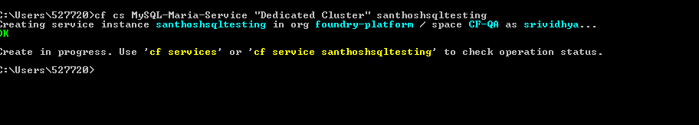
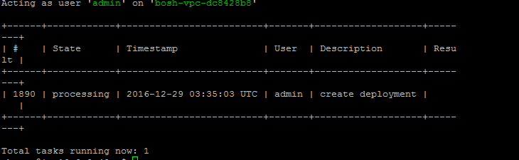
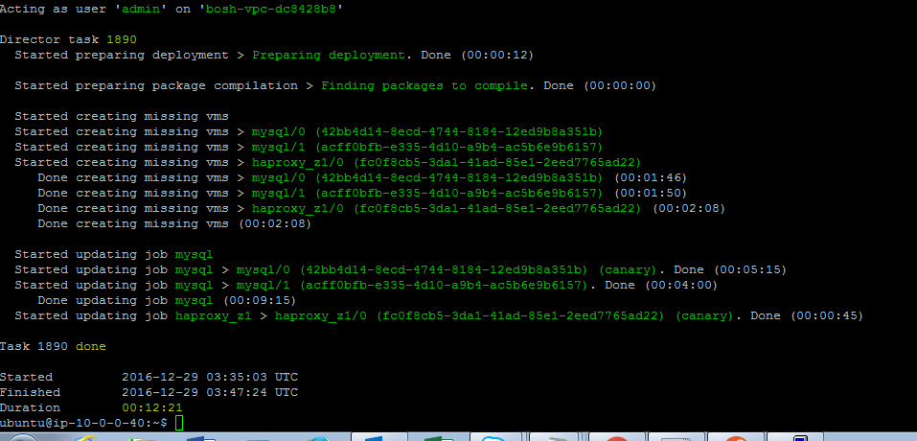

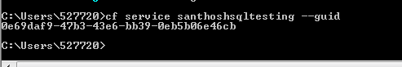
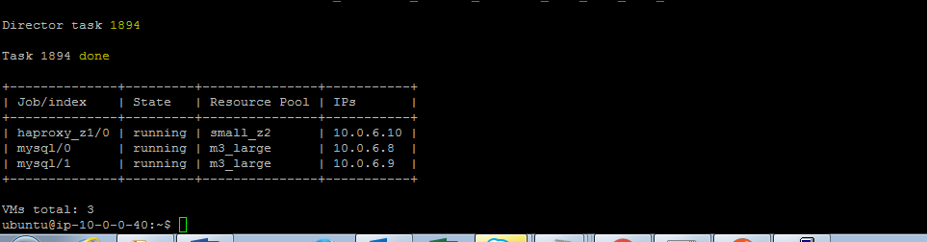
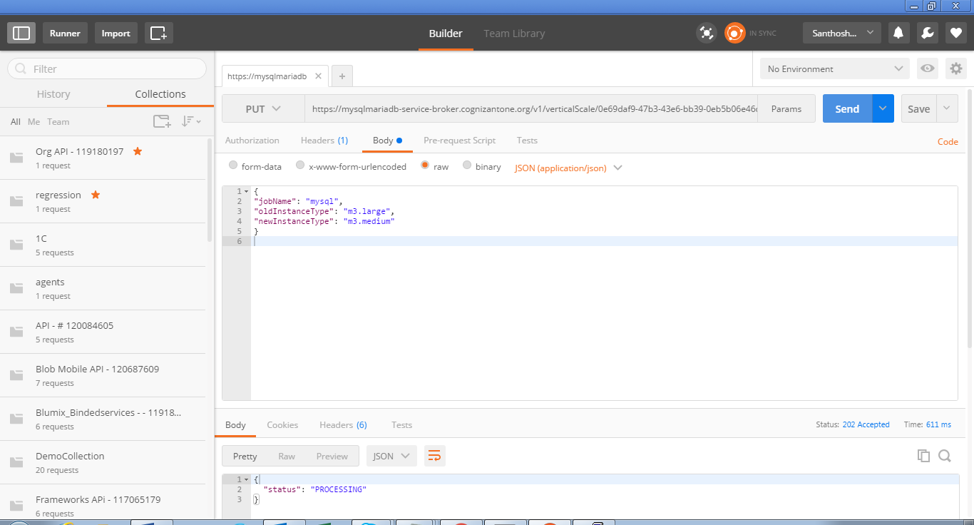
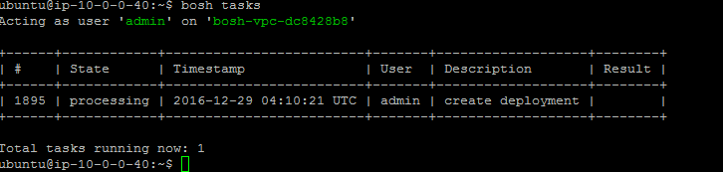
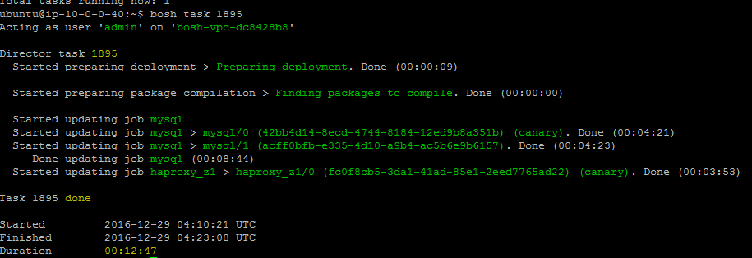
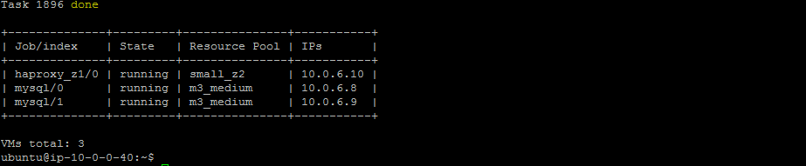

Change Log
Version Number | Changes Made
V1.0.0 | Initial baseline created on 26-12-16 by Srividhya
V1.1.0 | <Please refer the configuration control tool / change item status form if the details of changes are maintained separately. If not, the template given below needs to be followed>
V1.1.0 | Section No. | Changed By | Effective Date | Changes Effected

